Construction Program IAB Indianapolis Corporation Meeting
Friday – March 6, 2020
T&W Corporation & Church Solutions
3841 West Morris St., Indianapolis, IN
7:30 AM - 9:30 AM

MINUTES

1. Attendance:

Industry Members Present: Adam Cornelius, Steve Shehorn, Jeremy Bloomfield, Eric Harvey, Allen Galloway, Maurice Dunn, Mimi Law, Jackson Beckman, Jack Lautenschlager, Greg Vavul, Terri Truitt, Jared Redelman, Greg Taylor, Shane Mann, and Tim Howard.

IUPUI Members: Charlie McIntyre, Dan Koo, Bill White, Matt Ray, Marvin Johnson, Lydia Whiting, Kara Keller, and Zane Lee.

The membership extends a gracious thank you to T&W Corporation for hosting the March 6, 2020 IAB Meeting!

2. Approval of December 13, 2019 IAB Meeting Minutes:
Approved by a voice vote of members as written. The minutes are posted on the IAB Section of the Construction Management website.

3. Update on Program Director Search
Additional information forthcoming after spring break. There is one candidate interview scheduled for Monday March 23.

4. IAB Course Reviews:
2020 Spring Semester
Course Title | Instructor | IAB Reviewer
CEMT 11000 - Construction Accounting | Scott Stull | Jeremy Bloomfield
CEMT 28000 - Quantity Survey | Bill White | Mark Riffey
CEMT 34200 - Construction Cost and Bidding | Matt Ray | Allen Galloway
CEMT 48600 - Reinforced Concrete Design & Construction | Dave Kieser | Brad Bastin

One course review has been completed to date. We require industry input on course content to remain relevant to industry standards. A structured review form is provided to reviewers to provide consistence and for ease of tracking responses. This is a great way to meet students and instructors. The review generally consists of student questions regarding what they like about the course and gathering input on course content and instruction. This is a requirement for our ACCE accreditation.

5. IAB Membership Committee (Is membership corporate or individual/):
Corporate Membership - $250.00 annual dues 1/1 to 12/31 (After June 1st $125.00)
Program Staff - Complimentary
Retired Members - Complimentary
Graduates up to 3 years – Complimentary

Charlie stated that we need to reevaluate and revise the membership structure and categories/levels of membership and dues structure. Memberships and dues are currently based on individual membership only, and a corporate membership is for one person. There is no category for a corporation to pay a fee that would allow them to send whomever they desired to the IAB meetings. It may also be beneficial to have a job fair category.

One of the charges for the membership committee is to determine how to better define the corporate membership versus individual membership, and develop better definitions around membership classifications.

Volunteers requested. Our thanks to Jared Redelmen, Shane Mann, Adam Cornelius, and Greg Taylor. Charlie will provide a purpose statement for the committee, and set a deadline of May 1, 2020 for membership clarification.

6. IAB Job Shadowing - 2020 Spring Semester:
The job shadowing program (connecting students with industry mentors) is currently offered to freshmen in CEMT 10500 - Introduction to Construction Management.

Update from Bill White and CM IAB discussions.

Charlie stated that on the second day of the semester students are introduced to the job shadow program and provided a job shadow handbook. This semester 7 companies and 17 students are participating (See chart below). 6 students have completed the actual shadow and will provide a report to Bill White by the end of the semester. Allen stated that the benefit of a shadow student is that faculty try to match student interests with the specialties of firms participating. One sophomore also participated this semester at their own request. Maurice Dunn spoke about his experience with bringing in students and found it beneficial to show students the industry.

Charlie intends to move the shadow program to a sophomore course in the fall. Our thanks to all job shadow hosts.

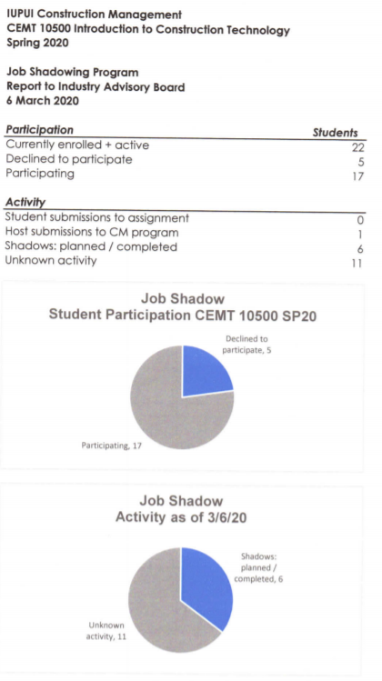

7. Capstone Group Mentor Program:
Report from the mentors: Jared Redelman, Andy Lock, Maurice Dunn, and Tim Howard.

Charlie provided an assignment capstone to mentors to complete this week.

Mentors meet with students once or twice a semester and guide teams on how to prepare estimates, schedules, and the oral presentation.

Tim Howard states that he’s been doing this for a couple of years and it has provided a great benefit to the students. T&W hired a full-time employee from the capstone team Tim mentored. Mentors discuss the status of the project, roles of each student, and the reality of what they are presenting. Students may not be on schedule. Tim discusses with students what is being worked on and then guides them to prepare the most complete presentation.

Capstone is a semester long course with milestones for sections of the written materials and presentation. Mentors should suggest students use a calendar. Mentors should have a copy of the syllabus so they can track the schedule. We anticipate 15 capstone students in the fall which will likely be 3-4 teams that need mentors.

8. 2020 Spring IAB Career Fair:
Employer Evaluation Results and general discussions.

Early February career fair was a success. 18 industry participants and 8 replied to the feedback survey – see handout.

Discussion on tracking student registration and attendance. Students were required to have industry representatives sign a sheet from each firm they visited with, but some representatives found that several students simply wanted the sheet signed without engaging in a conversation. Some students were disappointed they had work commitments and missed the career fair.

Discussion on ways to incentivize students to attend. One option suggested by a student is to only offer a business card to students after a satisfactory conversation and the business card could be given as extra credit and proof of attendance.

Current efforts to build student participation include flyers and email reminders of the career fair, and instructors push to have students attend. Links to the companies attending are provided in flyers and emails for students to learn more in advance of the career fair. A career fair larger than 20 industry participants would require a move to a larger area. Allen suggested possibly bringing in outside firms that want to pay a fee to attend, but board comments indicated that would limit the effectiveness of the fair and the ratio of firms to students. Our IAB fair is earlier than all campus-wide fairs and has a significant student to industry ratio.

9. IAB Financial Report (Jared Redelman, Treasurer):
Revenue, expenses, and of active members.

There are 33 paid members for 2020 and 4 unpaid members. 7 new members since 2019. Milestone, Indianapolis Airport Authority, United Consulting, Charles C. Bandt, Turner Construction, Ryan Fire Protection, and Strongbox Commercial.

Current summary of budget on next page.
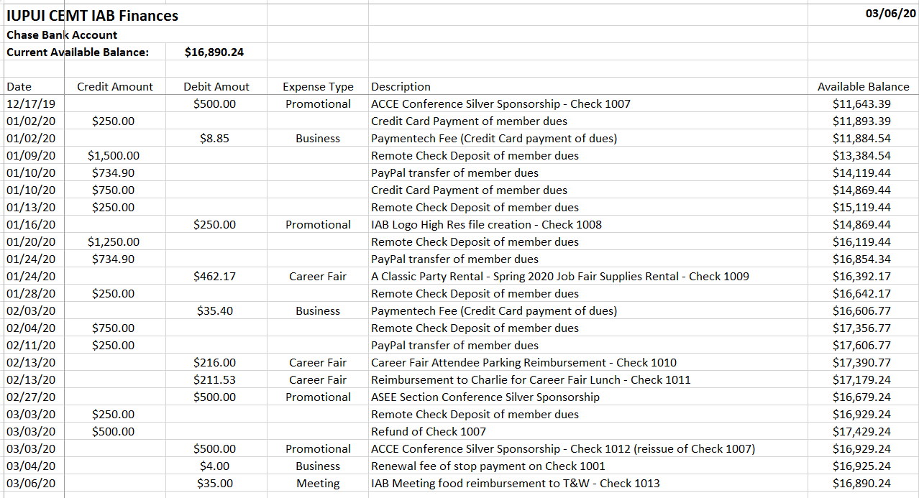

10. ACCE IAB Event/Conference:
Allen Galloway comments and general discussion.

Allen will scan and distribute the program brochure to IAB members. This will also be posted on IUPUI CM IAB website.

The conference consisted of a full day of industry activities regarding IAB’s, including workshops and panel sessions.

Top three takeaways from Allen:

- Need more females in the program and in the IAB. Capstone currently has 4 out of 20. Freshman class has 4 females out of class of 50. IAB should consider developing a program to recruit more females.

- More residential representation is needed in the PAB. There are several grants and scholarships available in this area. Allen and Eric will work to solicit Pulte, Arbor and D.R. Horton.

- Certify a trade program. More like an apprenticeship as part of the CM program.

Allen is now accredited to evaluate master’s CM programs. Allen will also be a member of the visiting team to review the Associates Degree Architectural Technologies program at Saskatchewan Polytechnic, Moose Jaw, Saskatchewan.

11. American Society of Engineering Education (ASEE) Illinois-Indiana Section Conference:
Saturday, March 28, 2020

The CM IAB is a Silver-Level Sponsor ($500) for this event. Charlie is an active member and Chair of the Illinois-Indiana Sections. 110 students and faculty registered to attend the conference that will include presentations from 45 research papers and studies, 27 student posters, and 2 workshops. Some UINDY engineering students and faculty participating.

This will be Hine Hall. Bob Bowen will be the keynote speaker. Anyone can attend. $195 registration fee.

12. General Discussion:
Discussion was held on the presentation by Dr. Steve Burgan regarding estimation uncertainty at the AACE Hoosier Section. This was based on the premise that line item in a conceptual estimate should have a confidence factor. He used a scaled confidence rating of 1-5 based on a multi-variant statistical analysis of each line item. Then categorized the cost as unlikely, likely and most likely. Most of us use a contingency line for uncertainty, but if you instead use a reserve number, at time of hard bid excess reserves can be reallocated to other line items thereby decreasing reliance on a contingency.

Jared Redelman has the presentation and we will request to share that with the IAB.

Ways IAB can support students:

We need an IAB meeting agenda line item to allow representative from the student body to update us on their meetings and ways we can assist them.

Scholarships would need to be run through the IU foundation, and a processing fee would be included. We currently support the ASC student competition through a matching grant. We send teams in the fall. Usually juniors and seniors, but they have offered for sophomores to participate. Great opportunity for students, and scholarships are available through this competition.

National Association of Home Builders (NAHB) also has a fantastic student competition.

One of our current mission statement objectives is to consider hosting a student awards banquet.

Marvin – update on the trophy case. Lock has been installed and awards may be placed there soon.

The Hall of Fame initiative is something that we need to continue pursuing.

13. Save the Dates:
Monday - April 20, 2020 at 3:15.
Capstone Group Rehearsals (University Library Auditorium). Four groups get about 30 minutes and time for questions. This is an opportunity to help guide the future of the industry.

Friday - May 1, 2020
Capstone Final Group Presentations (Location IUPUI across the hall from Lilly Hall at the university library auditorium) IAB meeting will begin at 7:30 a.m. Presentations will begin close to 9:30. Breakfast will be provided in Hine Hall. Please park in North garage, grab food in Hine Hall and then go to library auditorium.

After capstone we will convene for lunch back in the lab. After lunch we will conduct senior exit interviews. Charlie or Allen will circulate responses from December exit interviews to the IAB.

14. Action items for next meeting:
Report from membership committee.

Bill will update us on the status of the job shadow program.

Pick a date for career fair for next fall.

Call for capstone mentors.

Volunteers for the Indiana Counselors Association conference in November.

Marvin is seeking a capstone project for next fall, and will provide the project scope. Generally, capstone projects range from 5-8 million dollars, and needs to include a building with some infrastructure and parking.

Construction Program IAB Indianapolis Corporation Officers
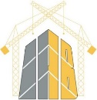 | Allen Galloway | Chair
 | Adam Cornelius | Vice Chair
 | Eric Harvey | Secretary
 | Jared Redelman | Treasurer

